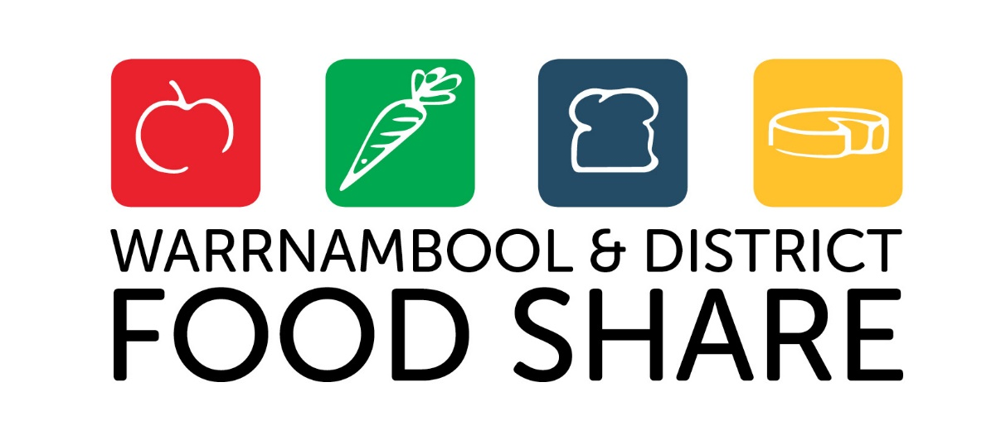

ANNUAL REPORT 2021/22

ABN: 49 926 759 768
Phone: 0428 197 715
Warehouse: 24a Harrington Road, Warrnambool, Victoria, 3280

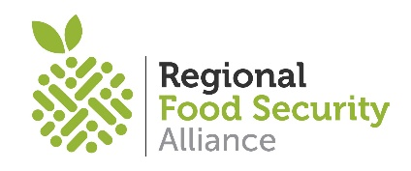
INDEX
A founding member of the
Reginal Food Security Alliance

CHAIR’S REPORT 3
EXECUTIVE OFFICER’S REPORT 4
OUR STATISTICS 5
OUR VOLUNTEERS 6
OUR SUPPORTERS 7
FINANCIAL STATEMENTS 9
OUR STARATEGY - VISION, MISSION, VALUES & GOALS 18

CHAIR’S REPORT
Welcome to our Annual General Meeting (AGM) for 2021/2022
Overall, this has been a very positive year for our organisation. We have managed to remain operational during another twelve months of COVID. Staff and volunteers have addressed many challenges to keep our warehouse open and emergency food distribution flowing throughout the entire pandemic, this is a credit to them all.
During the past year we have joined with other Victorian regional Food Shares to form the Regional Food Security Alliance (RFSA) funded by the government for one year to continue to provide the rural relief task forces across Victoria. Member organisations include Albury Wodonga, Bendigo, Geelong, Mildura, Shepperton and us.
Collectively we are in discussions with the Victorian Government to secure funding to allow us to continue to provide this essential service across the state.
As will be seen in our treasures report we have had a solid year financially. We have achieved one of our strategic plan goals in that we now have a good reserve that would allow us to purchase food stocks in case of an emergency or disaster in our region and keep operating if our current funding ceased.
Our AGM is the time to thank many people for their significant contributions to our organisation in both paid and voluntary roles.
I start by thanking our executive officer Amanda Hennessy for guiding the organisation through a very difficult and busy year. It’s never easy balancing all the needs of a mainly volunteer organisation but Amanda has managed this extremely well. Thanks also to Tonia Wilcox and Paul Frusher who have managed the warehouse and distribution throughout the year and our Trainee Trephy Grant for her administration support.
Our volunteers, what a mighty effort throughout this COVID filled year to keep turning up and ensuring all our agencies are provided with emergency food. You are the backbone of our organisation, and I cannot thank you enough for what you do for us.
Thank you also to local businesses who continue to support us with donations on a daily/weekly basis and thank you to our local community members who donate both food and provide financial assistance that allows us to keep operating.
In closing I must thank my fellow board members for providing support and good governance to the organisation. Also personal thanks to our secretary Jo McBain and treasurer Daniel Pearson for all the advice and assistance provided to me throughout the year.
We do have a change on the board at the AGM with Ray Lougheed retiring from the board after many years of service. Ray was our previous chair and held that position for five years. Thank you, Ray, for all you have done for this organisation, we wish you well for the future.
In closing I would like to thank you all for your ongoing support.
Mick White, Board Chair
Warrnambool & District Food Share

EXECUITIVE OFFICER’S REPORT
As the COVID-19 Pandemic and the cost-of-living have continued to put pressure on members of our community over the past 12 months we have focused on expanding our distribution networks across south west Victoria to reach more people who require support, working with 130 agencies and schools from Portland to Hamilton and across to Camperdown.
Our registered agencies include those working with disadvantaged youth, NDIS support, indigenous cooperatives, education providers, those providing emergency food relief as part of their wrap around supports and community meal programs.
With 177 tonne of emergency food distributed, 61,611 equivalent meals to the value of
$1.28 million we take this opportunity to thank all our partners for their ongoing support. It is with the support of over 80 organisations who provide us with in-kind services and products, ten supermarkets and four bakery partners who we collect from weekly that support the food rescue and distribution model, diverting 23 tonne of food waste from landfill annually.
We also thank our community who continue to support members of their community by donating pantry products, fresh produce and by making financial contributions to us. We take this opportunity to thank our new partner Volcano Produce who is supporting us with nutritional locally grown vegetables as supply has been impacted by natural disasters.
As a designated Regional Food Hub tasked to respond in a disaster situation, we secured State Government funding to purchase bulk food and support our operations in 2021/22. This rapid expansion required the implementation of additional warehouse shifts to deal with the growing demand. A demand we could not have responded to without our dedicated team of 100 volunteers.
Our 100 volunteers worked within changing pandemic restrictions to ensure our warehouse remained open throughout these challenging times. For this significant achievement and for their time, talent, friendship, laughter and smiles we thank them, for without their support we cannot do what we do.
Over the past year we have taken the opportunity to implement projects to improve our warehouse operations including a major refrigeration project and bulk storage systems upgrade with policies and procedures established to support our growing operations. Work continues to upgrade and streamline our processes with a view to supporting food equity and literacy.
Our community has remained strong and resilient throughout the past 12 months with community supporting community at every opportunity. You have supported us to operate a highly effective and sustainable service that allows food to be distributed via our registered partners across south west Victoria. For this we thank you.
Amanda Hennessy, Executive Officer
Warrnambool & District Food Share

OUR STATISTICS
130 Partners
100 agencies + 30 schools work with us to distribute emergency food across south west Victoria
162 Tonne Food Recovered
From 10 Partner Supermarkets + 4 Partner Bakeries = 45 pickups per week
177 Tonne Emergency Food Distributed
Distributed Food Value $1.28 Million
Equivalent Meals Distributed 61,611
An increase of 32 Tonne from 2020
100 Volunteers
Volunteer hours = 5025
50 weeks per year
Total Volunteer Value $236,000
21,769 People Receiving Food
10,310 Adults
11,459 Children
184 Tonne Food Diverted from Landfill
Total 2014 to 2021
Our Products and Services
Emergency Food Hampers - pantry, fresh, chilled, and frozen product
Emergency Food Boxes and Bags (nonperishable)
Schools Fresh Program (breakfast, lunch, and healthy snacks)
Community Meals Ingredients
Bulk Food Distribution (regional distribution to partner agencies)
Education and Food Literacy Programs
Warehousing and Logistics Services – the receival, warehousing and distribution of food product for partner agencies

OUR VOLUNTEERS
Our organisation can only operate with the support of our dedicated volunteers, without their significant support it wouldn’t be possible to achieve the outcomes listed in this report.
With 100 volunteers on our books, we run morning shifts to service our Schools Fresh Program, our agencies picking up emergency food hampers along with our community meals and our daily pickups from supermarkets and bakeries. Our afternoon shifts receive bulk food deliveries, process, pack, and breakdown product while carrying out a range of general warehousing duties.
Thank you all for your fabulous support, your skills, and the passion you bring to your volunteering.
This year we said goodbye to volunteers Ree Rundell, Diane Moloney, Sarah Vickers and Gerard Auld who have been with us for several years. We take this opportunity to thank Ree, Di, Sarah and Gerard for their wonderful support and friendship.
We also thank our corporate volunteers who support us weekly - McLaren Hunt Financial Group, South West TAFE, Wannon Water and Silvan Ridge Wealth. Thank you for your continued support of Food Share and of our community.
Thanks also to our volunteer board for their strategic guidance and support - Mick White (Chair), Jo McBain (Deputy Chair/Secretary), Daniel Pearson (Treasurer), Ray Lougheed, Adele Markwell, Alex McCulloch, Kane Horwill, Kylie Gaston, and Mark Fidge.
We are privileged to work with a wonderful group of volunteers who bring diverse set of silks and life experience to Food Share, and we take this opportunity to thank them for their time, talent, smiles, conversation, friendship, and passion.
At Food Share our mantra is community supporting community and our volunteers are at the front line of this ethos.

Thank You

OUR SUPPORTERS
We gain significant support from members of our community, business, and industry including:
- FareShare (frozen meals)
- Food Bank Victoria (food deliveries)
- Red Cross
- State Government (pandemic funding)
- Local Government
- Local Philanthropic Trusts
- The Gall Foundation
- Perry Cho Photography
- Breakwater Insurance
- Wannon Water Ripple Effect
- Warrnambool Bike & Rod Run
- Westvic Staffing Solutions
- Warrnambool supermarkets and bakeries (daily food rescue)
  - ALDI
  - Coles
  - Woolworths
  - Supa IGA Warrnambool
  - Port Fairy IGA
  - Gallo Bakery
  - Dennington Bakehouse
  - Chittticks Bakery
- Volcano Produce Tower Hill
- South West TAFE Bakery
- Local farmers collect food waste daily (no food goes into landfill)
- The Midfield Group (meat weekly)
- Saputo (cheese)
- Fonterra (milk weekly)
- Caravan Eggs
- Kangaroobie Meats
- Apostle Whey Cheese
- Chemists in Warrnambool (daily free boxes, approx. 15k per year)
- Meals on Wheels (WCC)
- Logistics – The Midfield Group, Paton’s Transport, Allens Freight
- South West Health Care
- South west Credit
- United Way Glenelg
- Seachange Portland
- Umney Design
- Gunners (web hosting)
- Bee Cool Refrigeration
We take this opportunity to thank our wonderful partners and
our community for their ongoing and generous support
OUR SUPPORTERS CONTINUED
- Maceys Bistro (fire wood fundraiser)
- Emcee Truss & Frame (fire wood fundraiser)
- Warrnambool Timber Industries (fire wood fundraiser)
- ACE Radio Network
- Fitzmedia Productions/Silver Ball Studios
- Norton Ford (servicing)
- McNeil BP (fuel)
- Good Year Autocare (tyres)
- Roma Britnell Office (printing)
- Southern Stay Disability Services (meeting rooms)
- Greyhound Club (meeting rooms)
- Warrnambool City Croquet Club
- Cleanaway
- Bunnings (gas bottles)
- Local schools (food drives) + Hands on Learning Programs (maintenance)
- Hire Australia
- eResources
- Cassign
- Star Printing
- Service clubs – Rotary, Lions, Probus, CWA, RSL
- Churches, community organisations and clubs (coordinating food drives)
- Local producers, farmers, and gardeners (donations of fresh vegetables and fruit)
- Local businesses (food donations) – Spotlight, Darriwill Farm, Cally Hotel & many more
- Fundraiser cash donation box Warrnambool locations:
  - Timor Street News
  - Bakers Delight
  - The Flying Horse
  - Southern Stay Disability Services
  - Dan Murphy
  - Godfreys
  - Scotty Seafood
  - Mr Brightside Pizza
  - Monaghan’s Pharmacy
  - The Cheesecake Shop
  - Gallo Bakery
  - Browns Bakery
  - The Meat Barn
  - Nextra Warrnambool
  - Country Life
  - Revive Nutrition Studio
- And so many more who support our operations

We take this opportunity to thank our wonderful partners and
our community for their ongoing and generous support
FINANCIAL STATEMENTS

WARRNAMBOOL & DISTRICT FOOD SHARE INC.
FINANCIAL REPORT
FOR THE YEAR ENDED 30TH JUNE 2022

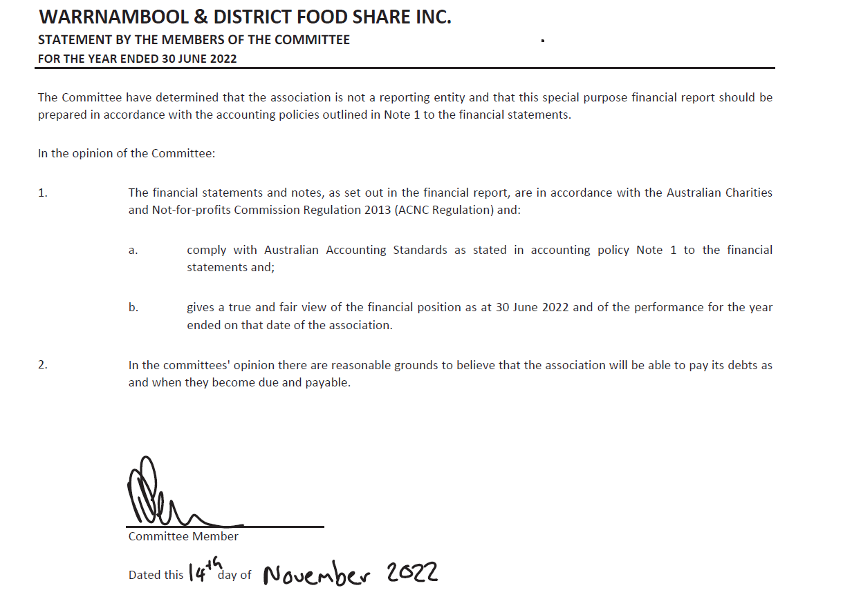

OUR STRATEGY
OUR VISION
Food Share will sustainably source and distribute food, so no-one goes hungry in south west Victoria
OUR MISSION
To operate a highly effective and sustainable service that provides food to be distributed to our partners across south west Victoria.
OUR VALUES
Integrity – We always act with integrity.
Accountability – We will be accountable for what we do in collaboration with our partners.
Respect – We demonstrate respect for all.
Responsiveness – We proactively & reliably meet food support demand across south west Victoria.
OUR CHALLENGES
- Maintaining financial stability
- Addressing food insecurity in our region
- Accommodating growth in demand

OUR OPPORTUNITIES
- Forming active community partnerships
- Broaden community outreach across south west Victoria
- Partnering Governmental and community programs
- Reducing food waste to landfill
OUR GOALS
Goal One - Maintain Financial Sustainability
Objectives:
- Maintain 12-month operating budget in reserve
- Maintain disaster recovery fund to purchase of emergency food
- Secure government funding for period 2023 to 2025
Goal Two - Increase awareness and understanding of Food Share’s essential role
Objective:
- Increase our brand awareness across south west Victoria
Goal Three - Strengthen our partnerships to improve sustainability and increase our service impact
Objective:
- Membership of Regional Food Security Alliance (RFSA) providing collective voice to Government
- Maximise collective food purchasing via RFSA membership
Goal Four - Continually review our operational model and structures
Objectives:
- Maintain a positive, inclusive, and nurturing culture for our volunteers and staff
- Implementation of system improvements and shared services

